Vehicle Management System To Reduce The Risky Factors Using Embedded Technology Enhanced With Wi-Fi

Harini B

Abstract. Medium to medium is a quickly developing technique, which renders enhanced client servicing, occupation betterments via best usage of assets, enhanced techniques and production via communicating between distant machinery and vehicle Management System. Here, the vehicle status and location can be determined. Vehicle Tracker utilize GPS devices to give an account of the location information to the server. Accident is unplanned harm, is an unwanted, accidental, and unintentional consequence that must have been precluded had considerations and if there is no proper system human lives will be in danger. The main purpose of this technology is to identify an accident and give an indication signal to the control room, so that the affected individual can seek some support. The severity of the incident can be identify from the control room, without going to the sot in person. If this model is fix all vehicle, it will be very useful to identify how many vehicles undergoes in that specified accident and the extent to which it has taken place. In order that the aid from control room will be able to rescue and protect driver or passengers. The present board designed the tracking of vehicle and systems for accidents alert that makes it extremely valuable and utile. This board indicates to us driver abnormal condition and as well as accident identification. It additionally identifies the driver drowsiness.

Keywords: Asset utilization, Drowsiness, Unintentional injury, Vehicle management system

Introduction
In accident detection, using smart-phone is propose. However, if smart phones are utilize to identify accidents; in that case, there must be quiet number of filters in-built to prevent false warnings. The classification mechanism is construct by accumulating datasets from simulation of three accident cases that aids in creation of an artificial intelligence-based classification software [1].Hence; it is difficult to identify minor accidents such as sideswipe collision. If an IR sensor is, utilize for accident identification, and then the model makes use of GPS, GSM for localization and communication. The IR sensor processes the radiation emit by each object. An Android dynamic time warping based smart phone architecture of the accident identification model together with experimental outputs are utilize [2]. In accident identification utilize airbag model is suitable only for four-wheelers; it is not applicable for two wheelers. However, there must be a model that is suitable for all kinds of transport. The
1

identification technique is apply onto a server utilizing pattern matching based on dynamic time warping [3]. There are some issues related to accident identification utilizing humanoid touch phone. Since every touch-phone model will possess varied processors with different working speed. Hence, the applications performance may deteriorate in few smart phones. In the proposed work, several ultrasonic sensors utilize in the identification of accidents. The objective is to apply the algorithms into the android phones in-built high tech sensors that are associated with GIS, GPS and Geo fence technologies [4]. An ultrasonic sensor is utilize for distance computation. The return time taken by the wave, decides the displacement from the sensor to the obstacle. The usage of ultrasonic sensor for accident identification has numerous advantages. It enables to identify accidents not only in several road situations such as junctions, subway or in service roads but also under varied climatic circumstances such as rains, foggy weather. Ultrasonic sensor seems to be very efficient since it rely on the principle of sound wave propagation. Also sound waves can propagate simultaneously and effectively through all kinds of matter such as solid, liquid and gas. This feature enables ultrasonic sensor to be an appealing alternative for automatic accident identification. There are a number of applications available [13-26].

Existing system
An affordable ultrasonic sensor is utilize to identify an accident. There are several state-of-the-art methods for automated identification of road accidents. They are using Android mobile, infrared sensor, airbag system. This system utilizing dual ultrasonic sensors is suitable for identification of road accidents. Varied computer simulation are execute utilizing MATLAB, to determine the factors that have an effect on the identification of accidents utilizing ultrasonic sensor. Based on the factors the model utilize two ultrasonic sensor modules HCSR04. First sensor module is mount on the vehicle front windscreen and the second sensor is fix on the vehicle rear windscreen. Then the distance from the sensor modules to their corresponding bumpers is evaluate and are termed as threshold distance 1 and threshold distance 2. When an object is displacing away from the vehicle, the distance between them is generally greater than the preset threshold distances. The identification of closed eyelids is effective even during varied circumstances, utilizing camera of any humanoid mobile [5]. A novel driver behavior detection framework that at its core makes use of in-vehicle Wi-Fi signals [6].When an object collides with the vehicle, the threshold distance is infracted and the processing system goes to ON condition. The system instantaneously determines the vehicles location utilizing GPS and sends to the rescue mission utilizing GSM. However, there are several disadvantages with respect to these approaches [28].The disadvantage of the existing system is as ultrasonic sensor’s measurement relies on the velocity of sound waves, so it requires prior calibration. The simulation results depicts that, as the velocity of the vehicle enhances, the fault in distance measurement simultaneously increments. This fault must be counterbalance by standardizing the ultrasonic sensor. With the help of machine learning, identified patterns in the behavioral and physiological factors that together helps to identify drowsy states from alert states for explicitly during driving[7].This system is totally hypothetical.

Proposed System
The proposed system concisely reexamine chosen road accident identification methods and intend a resolution. In these methods, a model is utilize that automatically identifies an accident in a quick span of time and alerts the emergency center and police department with an outline of the incident. The proposed system is to provide an approach about transportation unit as well as the vehicle condition is update in the server. The driver drowsiness can be identify by using the camera. If any accidents occurs, it is identify by the vibration sensor. If any deviation happens, the buzzer will alert the driver and automatically reducing the motor speed. All the details should be update in the server via Wi-Fi. In some systems, MATLAB/Simulink functions as the primary software utilize in development of this application. Images and other data types are acquire utilizing Android devices sensors [8]. The accident location can be update in the server to intimate the police station, neighbors and a message is convey to the relatives. The Heartbeat of the person is identify by using a heartbeat sensor .In this proposed system developed an affordable and reliable system using pic microcontroller. Several algorithms for tracking heart rates while performing heavy exercise utilizing an 8-sec mean of heart rates that does not precisely

captivate huge changes in instantaneous heart rates[9].The fig 1 denotes the block diagram of the proposed model. The 230 volts is convert to 12 volts by using the SMPS. Vibration sensor is utilize to identify an accident. There are several methods for the identification of road accidents automatically. These include smart-phones, Infrared sensor (IR sensor), camera, vibration sensor is to be measuring the driver heartbeat count, drowsiness and vibration of the car, that data will be continuously uploading the server via internet. This system is convenient since it utilize vibration sensors for detection of road accident. To assess the operation of the proposed framework of the block diagram shown in fig.1, different location and other factors will be monitoring the PC in the police or emergency department. The driver drowsiness will be detect by using camera. Heartbeat and drowsiness is detected by this system and based on the threshold condition the motor would be automatically stopped. These kinds of data are transmit to the server via internet using Wi-Fi with GPRS connection. GPS is use to find the location where the incident has occur. Then the emergency team and police department will rescue the respective individual. In addition, a buzzer will give an alert surrounding the accident spot. The hardware components used are PIC microcontroller, raspberry pi, SMPS, DC motor, heart beat sensor and GPS.
A compiler is use to transform the source code written in a programming language into another computer language. The need for transformation is to create an executable program. Python is use in programs. It is a high-level language for easy programming.

Camera
Motor
Driver
Motor
Buzzer
Buzzer
Driver
Heart
Beat Sensor

Raspberry PI
GPS
Keypa

PIC Micro controller
Wi-Fi

Fig 1 Block Diagram of proposed system

Vibration Sensor

Simulation Results
These are the server upload data of the proposed system. The server data is vibration condition, heartbeat condition, eye drowsiness and location with date and time. These results will be continuously update in the server. In the server, the huge amount of data will be stored. That total data count also updated. Fig. 2. Shows the server output of the data received on particular date and time, vibration of the car is normal, heartbeat of the driver is normal eye drowsiness or eye status is normal.
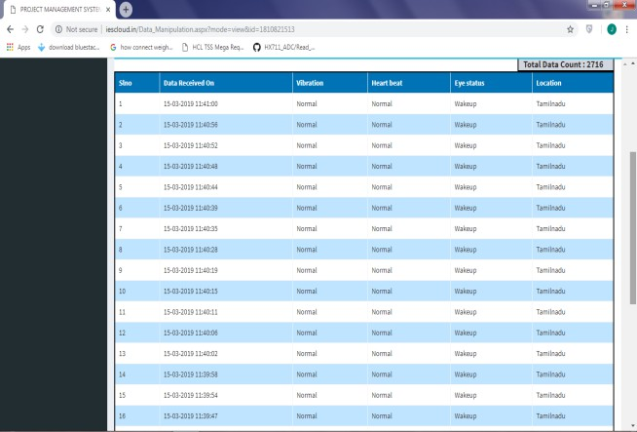

Fig 2 Server display output
The simulation of proposed system demonstrates a driver drowsiness identification model utilizing Open CV in Raspberry Pi environs having a single camera view. The proposed model initially identifies the face utilizing Haar Cascade Classifier and other facial landmarks utilizing Drib predictor.
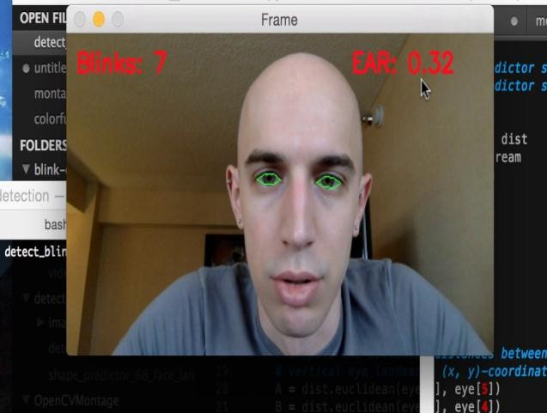
Fig 3 Active Eye detection simulation output

Facial landmarks associated with eyes are fetch and Eye Aspect Ratio (EAR) is obtain. EAR is closely noted ceaselessly, if the value lies within a threshold value and never raises again connotes driver eye is closed. The Fig.3 shows the active eye of the person. Drowsiness is detect from this technique; the simulation output of the drowsiness of human eye is shown Fig.4.

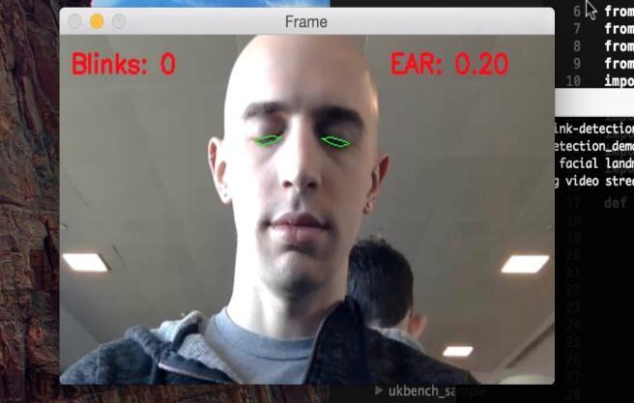
Fig 4 Drowsiness eye detection simulation output

Hardware Implementation
The vehicle accident detection system is implement by the requiring components that is properly to connect as show in the block diagram. First of all the entire system will be ON when the person start the engine of the vehicle. SMPS is gives supply voltage from 230V battery to 12V supply for the proposed system, when the engine is start the LED will be blinking and automatically Wi-Fi is connected to the mobile hotspot and motor will be rotate(i.e. vehicle movement). Compared with traditional piggybacking schemes, CoS is more reliable to transmit control messages from one node to many nodes[10].For that any certain time the vibration sensor sense the vibration above the threshold value to alert the surroundings area by using buzzer and also the intimation will be sent to the emergency and police department via internet. The hardware implementation of proposed system is show in Fig.5.
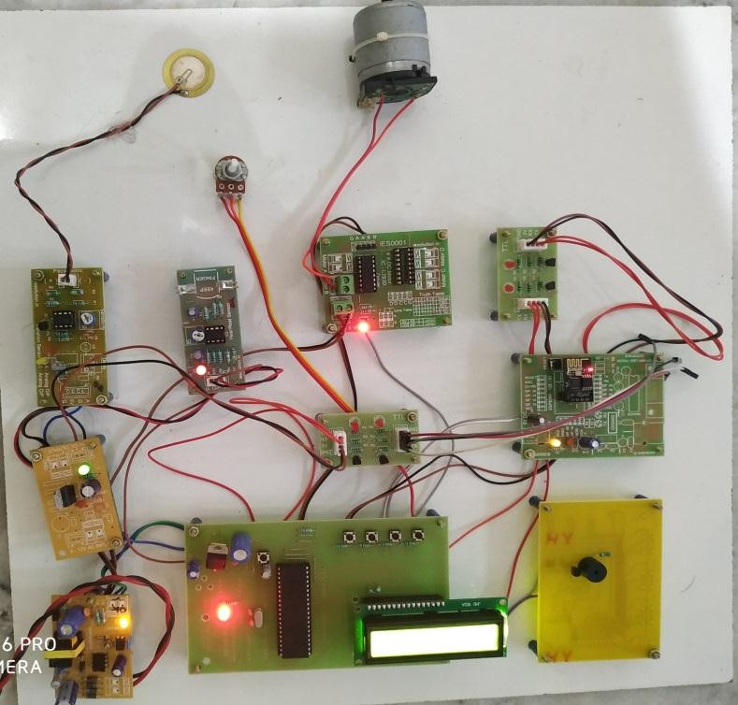
Fig 5 Hardware implementation of proposed system
A face image is first study utilizing a landmark identifier and a group of interest points is obtain [27]. Facial landmarks associated with eyes are fetch and Eye Aspect Ratio (EAR) is obtain. EAR is closely noted ceaselessly, if the value lies within a threshold value and never raises again connotes driver eye is closed. The measuring value will be display by using the LCD display. The Fig.6 is shown in driver was wakeup condition that is the eye status of the driver.

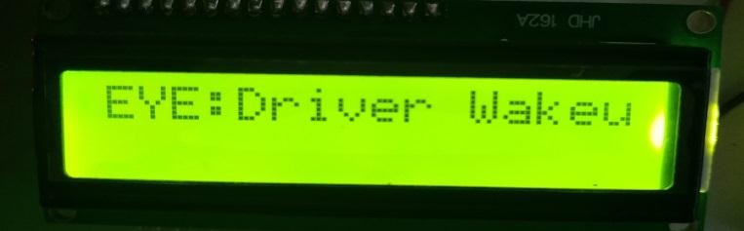
Fig 6 Eye detection display output
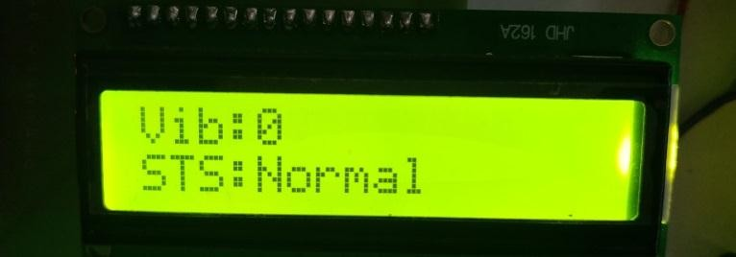
Fig 7 Vibration display output

The vibration sensor sensing the vibration value of the vehicle that is vehicle gets vibration value below or above the threshold value that is always exhibit by LCD display. The initial functioning band is focus at 850 MHz that provides for GSM applications, while the forthcoming frequency bands are focus at
1.57 GHz and 2.4 GHz provides for GPS and Wi-Fi wireless applications [11, 12]. For example the vibration sensor value is ‘0’ that is shown in Fig.7.

Conclusion
Accident prevention denotes the plans, formulations and activities taken to avert or cease an accident prior to its happening. Accidents are subdivide as unplanned and unpredicted events may leads loss of property and human kind. In this project, the methods to implement certain autonomous features in a regular car was describe. Using this prototype the hardware was design and built. With the help of vibration sensor and GPRS the accident, happened place was update in server using Wi-Fi module, which is connect to our mobile hotspot. From the server the SOS signal will be send. The driver drowsiness will be detected using camera, which is interface with raspberry pi, and heartbeat will be detect. The buzzer will be alert to the surrounding people of the accident area. This project is to be save the people life from critical situation.

Future Enhancement
The accident detection and avoidance system has varied proficient challenges that raise when data analytics for collision avoidance. Future research opportunities aims for implementing data analytics in safety precaution in fields like traffic management, adaptive network security, and data forensics.

